AssetOpsBench
Detailed Interview Handbook
Industrial Multi-Agent AI for Asset Operations and Maintenance
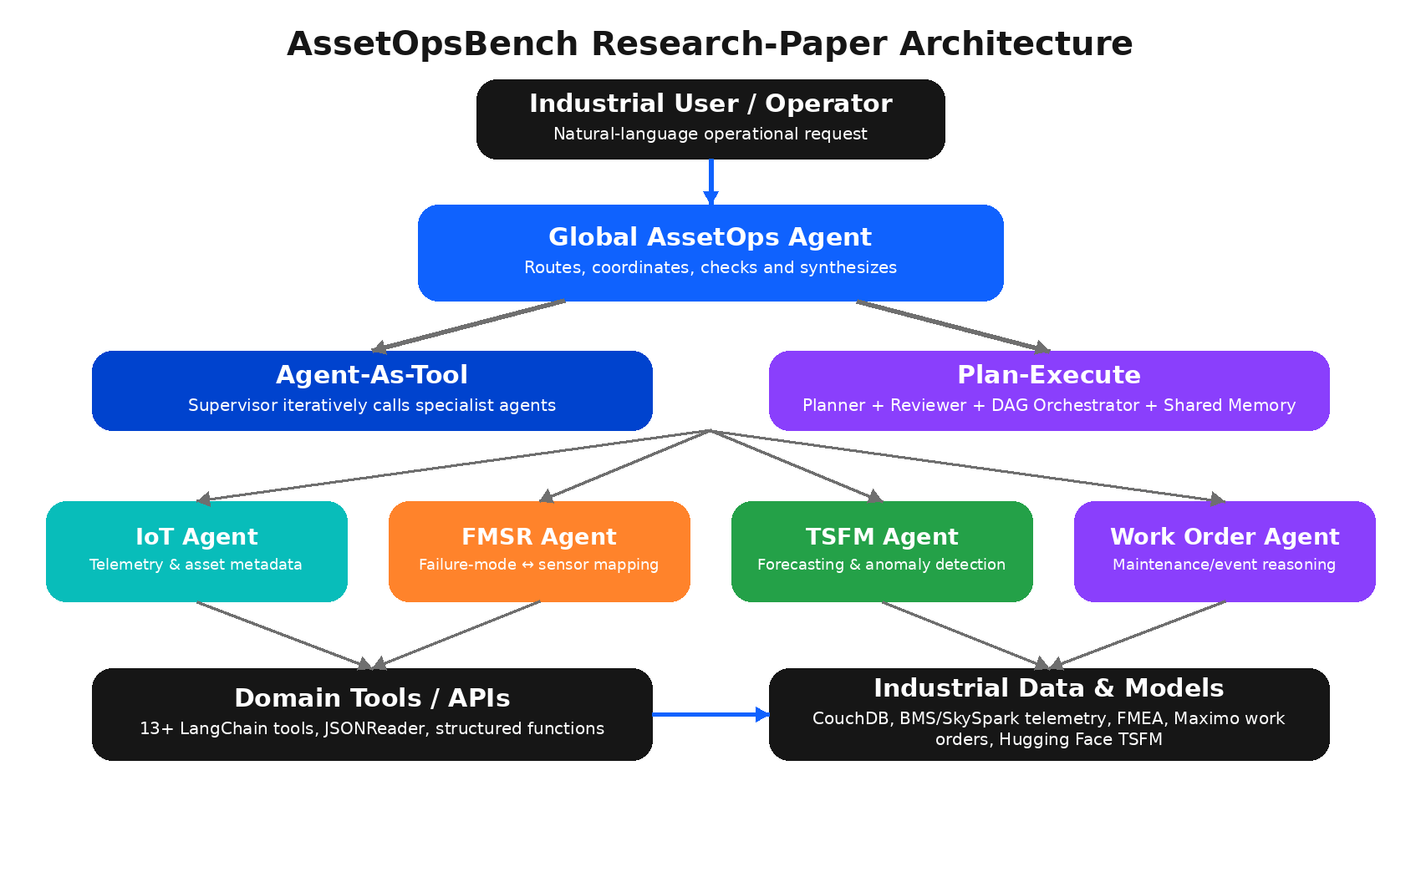
Purpose: confidently explain the project in 5–10 minutes and answer technical follow-up questions.
Grounded mainly in the 2026 research-paper architecture (141 scenarios, four specialist agents).

How to Use This Handbook
This document is intentionally more detailed than a five-minute answer. Read Sections 1–6 to understand the project, use Sections 7–11 for technical follow-ups, and revise the ready-to-speak scripts near the end before the interview.
Version note
The research paper describes a benchmark with 141 scenarios, four specialist agents, LangChain-style tools, CouchDB and two orchestration strategies. The live GitHub main branch has continued to evolve, including native MCP servers and additional runners. In an interview, clearly state whether you are explaining the research-paper version or the latest repository version. This handbook focuses on the research-paper version and adds a short note about the current repository where useful.

Contents
1. Project in one minute
2. Industrial problem and objectives
3. Dataset and benchmark scenarios
4. Complete system architecture
5. Detailed explanation of every agent
6. Tool catalogue and work-order business objects
7. Orchestration: Agent-As-Tool vs Plan-Execute
8. End-to-end execution example
9. Evaluation, results and failure analysis
10. Technology stack and why this is not RAG
11. Production design, scalability and safety
12. Interview questions and follow-up answers
13. Five-minute and ten-minute speaking scripts
14. Honest contribution positioning and final cheat sheet

1. Project in One Minute
One-sentence definition
AssetOpsBench is an IBM Research benchmark and simulated industrial environment used to build, orchestrate and evaluate domain-specific AI agents that work with sensor telemetry, failure models, time-series models and maintenance records.

Traditional machine-learning systems usually solve one narrow task, such as forecasting a temperature signal or classifying an anomaly. Industrial operators, however, ask broader questions that require multiple kinds of evidence. For example, “Why is the chiller efficiency dropping?” may require sensor retrieval, physical failure reasoning, time-series analysis and maintenance-history review. AssetOpsBench represents each capability as a specialist agent and coordinates those agents through a global AssetOps Agent.
The project is also a benchmark. It does not only produce answers; it records the complete agent trajectory and measures whether the agent completed the requested task, retrieved the right data and verified the result. This makes the framework useful for comparing LLMs and orchestration strategies in realistic industrial workflows.
Project element | Simple explanation
Industrial sandbox | A Docker-based, CouchDB-backed environment that imitates access to industrial data and APIs.
Four specialist agents | IoT, FMSR, TSFM and Work Order agents, each responsible for one operational domain.
Global coordinator | The AssetOps Agent selects agents, passes context and builds the final answer.
Two orchestration strategies | Agent-As-Tool uses iterative delegation; Plan-Execute creates and reviews a task graph before execution.
Benchmark and evaluation | 141 expert-created scenarios, LLM-as-Judge scoring, reference-trace scoring and failure analysis.

Interview opener
“AssetOpsBench is a multi-agent industrial AI benchmark. A global coordinator receives an operator’s question and calls specialist agents for telemetry, failure reasoning, forecasting and work-order analysis. The framework then evaluates the full execution trace, not only the final text answer.”

2. Industrial Problem and Project Objectives

2.1 The real industrial problem
Industrial assets such as data-center chillers, air-handling units, compressors and pumps continuously generate operational information. Some information is numerical and time-dependent, such as temperature, flow, load and power. Other information is textual or structured, such as failure-mode libraries, alerts, event logs and maintenance work orders. These sources normally live in different systems and use different identifiers and terminology.
A maintenance engineer therefore has to perform several manual steps: find the correct asset, identify relevant sensors, inspect historical values, understand which physical failures could produce those symptoms, check whether the behavior is abnormal, and compare the finding with prior maintenance history. The difficulty is not merely “finding data.” It is connecting physical evidence, time, maintenance context and operational intent.
Pain point | Operational consequence
Data is distributed across BMS, IoT, FMEA and EAM systems. | Engineers spend time switching between tools and reconciling identifiers.
Sensor data has gaps, inactive periods and flat values. | A model can create false forecasts or false alarms unless it understands equipment state.
Failure terminology differs from sensor-tag terminology. | The system must map a physical failure such as compressor overheating to measurable signals.
Work orders are historical, irregular and partly textual. | Root-cause and replacement decisions require coding, aggregation and temporal reasoning.
A wrong answer can trigger unnecessary maintenance. | The agent must verify evidence and disclose uncertainty rather than confidently guessing.

2.2 Main objectives
- Create a realistic benchmark: Use expert-authored tasks grounded in actual industrial data and operational language.
- Build modular specialist agents: Separate telemetry, failure mapping, time-series modelling and maintenance-history reasoning.
- Study orchestration: Compare iterative Agent-As-Tool delegation with upfront Plan-Execute orchestration.
- Evaluate reliability: Measure task completion, data correctness, result verification and reference-trace alignment.
- Discover failure modes: Analyze trajectories to identify where agents misunderstand, overstate completion or fail to recover.
- Support reproducibility: Package tools and data access in a Docker-based simulated environment.
Business value
The long-term goal is decision support that shortens diagnosis time, improves condition-based maintenance and reduces unplanned downtime. The benchmark itself does not claim to replace maintenance engineers; it tests whether agents can reliably assist them.

3. Dataset and Benchmark Scenarios
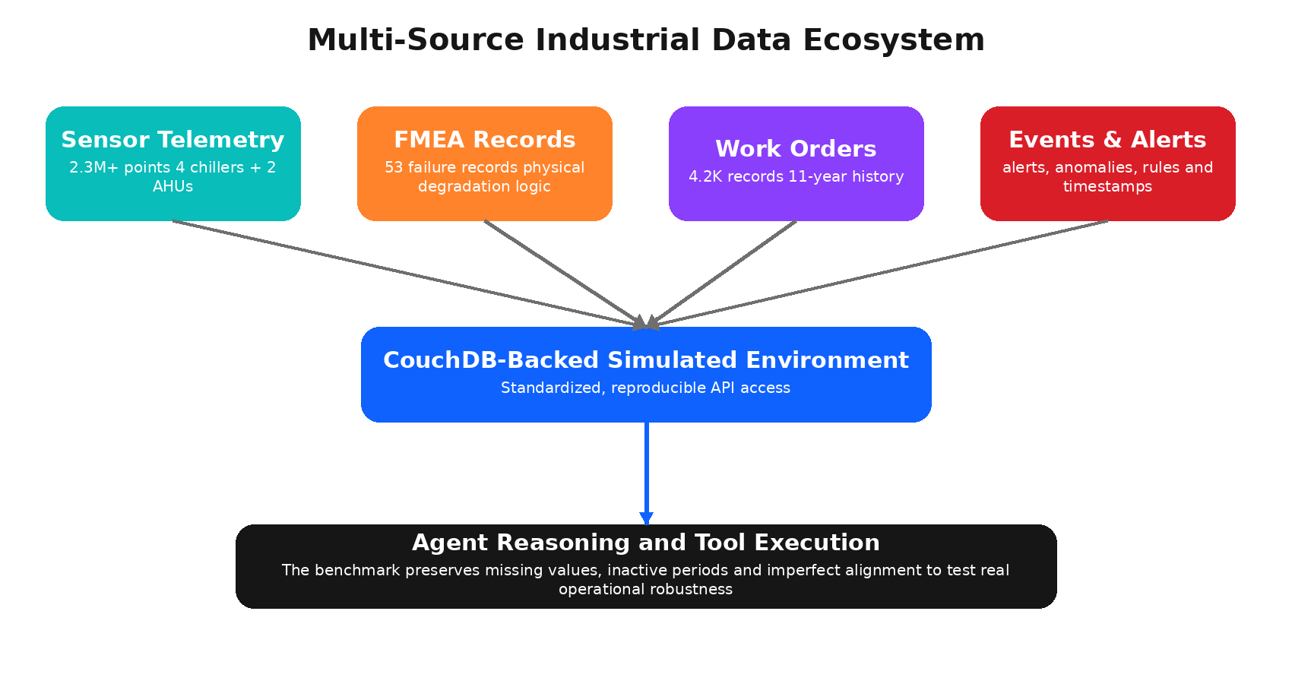
Figure 1. Multi-source data foundation used by AssetOpsBench. Diagram recreated from the paper description.

3.1 Data sources
Data source | Scale | What it contains | Why the agent needs it
Sensor telemetry | 2.3M+ points across 6 assets | Return temperatures, percentage load, condenser flow, run status and other measurements. | To inspect current/historical behavior and prepare data for forecasting or anomaly detection.
FMEA records | 53 entries across 3 assets | Failure location, component, degradation mechanism, influences, symptoms and detection opportunities. | To connect physical failures with measurable indicators and possible maintenance actions.
Work orders | 4.2K records over 11 years | ISO failure codes, timestamps, equipment context, preventive/corrective maintenance and linked events. | To identify recurring problems, maintenance trends and recommended actions.
Events, alerts and rules | Multiple linked objects | IoT alerts, ML anomalies, alert rules and causal mappings. | To relate abnormal observations to operational events and failure codes.

3.2 Why the data is intentionally imperfect
AssetOpsBench preserves real operational artifacts instead of aggressively cleaning them. Sensor streams can contain missing values, inactive periods and flat segments. Work orders can be written retrospectively and may not align perfectly with sensor timestamps. These imperfections are useful because a reliable industrial agent must detect when data is insufficient, identify equipment off-periods and avoid inventing results.
Important example
If a chiller was not operating during the requested forecasting window, the correct answer may be “insufficient active-operation data,” not a numerical forecast. This tests operational reasoning, not only tool syntax.

3.3 Scenario design
The benchmark contains 141 scenarios created through an 18-month collaboration with reliability engineers. There are 99 single-agent scenarios and 42 multi-agent scenarios. Queries are written in operator language rather than database terminology, forcing the agent to translate intent such as “energy consumption” or “chiller performance” into assets, sensors, time ranges and tools.
Lifecycle phase | Typical benchmark task
I. Asset configuration | Retrieve FMEA information, identify assets/sensors and define KPIs.
II. Model selection and analysis | Choose a forecasting/anomaly model or identify historical failure evidence.
III. Monitoring and execution | Retrieve live/historical data, configure thresholds and enforce guardrails.
IV. Maintenance and response | Summarize health, recommend action or create/analyze work orders.

4. Complete System Architecture

Figure 2. Complete research-paper architecture: global coordinator, orchestration strategies, specialist agents, tools and industrial data layer.

4.1 Layer-by-layer explanation
1. The industrial user asks a natural-language question without needing to know database names or API parameters.
2. The global AssetOps Agent interprets the intent and decides whether one or several domain agents are required.
3. The orchestration strategy controls how work is delegated. Agent-As-Tool chooses agents iteratively; Plan-Execute creates and reviews a dependency graph first.
4. Each specialist agent uses its own reasoning pattern and tools. IoT, FMSR and TSFM use ReAct-style tool calling; the Work Order agent uses CodeReAct because maintenance analysis often requires programmatic filtering and aggregation.
5. Tools retrieve structured evidence from the CouchDB-backed sandbox, industrial datasets or the pretrained time-series model.
6. Intermediate observations are returned as structured results and passed through shared context or memory.
7. The coordinator synthesizes a final answer with evidence, limitations and actionable next steps.
8. The benchmark records the trajectory and sends it to the evaluation pipeline.

4.2 Why a multi-agent architecture?
A single agent with every tool has a larger prompt and more tool-choice ambiguity. Specialist agents reduce complexity by limiting each agent to a domain-specific tool set and examples. The paper’s single-agent baseline performed far worse, supporting hierarchical specialization.

5. Detailed Explanation of Every Agent
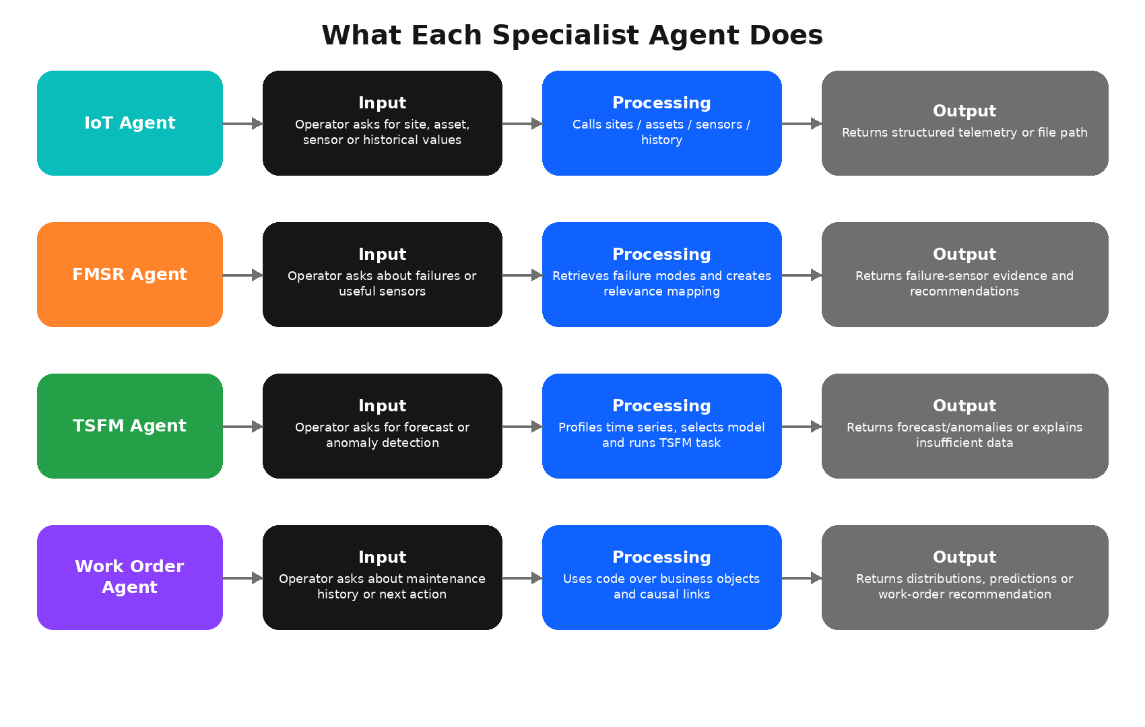
Figure 3. Responsibilities, processing and outputs of the four specialist agents.

5.1 Global AssetOps Agent (Coordinator)
The global AssetOps Agent is the entry point. It does not directly perform every industrial calculation. Instead, it decides which specialist has the correct capability, formulates a sub-request, stores intermediate results and determines when enough evidence has been collected.
Aspect | Explanation
Input | An operator question, such as “Why is Chiller 6 showing lower efficiency?”
Core decisions | Is the task single-domain or multi-domain? Which agent should run first? Is clarification required? Has the task been completed?
Output | A synthesized final response and an execution plan/trajectory.
Risk | Incorrect routing, stopping too early, asking the wrong agent or failing to request clarification.
Mitigation | Agent descriptions, in-context examples, structured sub-agent outputs, review fields and explicit termination logic.

Interview answer
“The coordinator acts like a maintenance lead. It understands the overall problem, delegates domain tasks, keeps shared context and combines the specialists’ outputs into one operational answer.”

5.2 IoT Agent
The IoT Agent is the structured-data access specialist. It translates human phrases into site, asset, sensor and time-range parameters. It can discover the available hierarchy before requesting telemetry, which is important because users may know the physical asset name but not its internal identifier.
Stage | What happens
Discover | List sites, assets and sensors to resolve names and identifiers.
Retrieve | Call the history tool with site, asset, start time and end time.
Package | Return counts, time bounds, metadata and often a JSON file path containing observations.
Validate | Check that the requested asset, sensors and period were used.
Escalate | If a user’s request is ambiguous or the asset is inactive, return the limitation instead of guessing.

Example: The user asks for chilled-water leaving and return temperatures for asset CU02004. The IoT Agent first confirms the site and asset, then retrieves the history and returns a structured response with the number of observations and the JSON file location. A downstream tool such as JSONReader can read the full array only when required, preventing very large data from being unnecessarily copied through the agent context.
IoT Agent in one line
“It is the bridge between natural-language operational questions and structured sensor APIs.”

5.3 FMSR Agent
FMSR stands for failure-mode and sensor relevancy reasoning. The FMSR Agent addresses the semantic gap between reliability-engineering concepts and physical sensor tags. A failure mode such as bearing wear, impeller erosion or compressor overheating is not itself a sensor name. The agent must determine which measurements can provide useful evidence for that failure.
Input type | Example | Agent action
Asset-to-failure query | “What failure modes apply to a centrifugal chiller?” | Retrieve FMEA failure modes for the asset class.
Failure-to-sensor query | “Which sensors are useful for compressor overheating?” | Compare failure mechanism and detection opportunity with available sensors.
Asset + sensor + failure query | “Find the most relevant sensor on Chiller 6 for this failure.” | Use the LLM-driven mapping function to rank or explain relevance.

The important tool is the failure-mode and sensor relevancy mapping function. It receives a string containing the asset, candidate failure modes and candidate sensors. The LLM then uses FMEA knowledge, sensor semantics and detection opportunities to produce a mapping. This is generative semantic reasoning, but it is not vector retrieval. The source evidence is structured FMEA and sensor information.
FMSR Agent in one line
“It converts reliability-engineering failure knowledge into a practical list of measurable sensor evidence.”

5.4 TSFM Agent
The TSFM Agent performs model-driven analysis over time-series data. TSFM means Time-Series Foundation Model. Instead of asking an LLM to numerically forecast sensor values, the agent uses the LLM to select and configure a pretrained time-series model, while the forecasting or anomaly calculation is carried out by the specialized model/tool.
Responsibility | Explanation
Task discovery | List supported AI tasks, such as forecasting and anomaly detection.
Model discovery | List compatible pretrained forecasting checkpoints.
Data preparation | Use a dataset path, timestamp column and selected target variables.
Forecasting | Generate future values for one or more sensors/KPIs.
Fine-tuning | Adapt a pretrained model to a new dataset when the scenario requires it.
Anomaly detection | Use model predictions and conformal logic to identify abnormal observations.
Operational-state handling | Infer on/off periods, resample to a common 15-minute grid and apply limited imputation only when appropriate.

A critical reliability behavior is abstention. If the equipment is off or the historical window contains too many zeros, the agent should state that the data cannot support a valid forecast. This is better than producing a visually plausible but physically meaningless curve.
TSFM Agent in one line
“The LLM configures the analysis, but the time-series foundation model performs the numerical forecasting or anomaly detection.”

5.5 Work Order (WO) Agent
The Work Order Agent reasons over maintenance business objects rather than a simple sensor API. Work-order questions often require joins, filtering, trend calculations and causal linking between equipment, alerts, anomalies, failure codes and maintenance actions. For this reason, the paper uses CodeReAct: the agent can write or execute code to manipulate structured objects and produce the answer.
Typical question | Required reasoning
How many corrective work orders occurred each year? | Filter by asset/type, group by year and count.
Which failure code is recurring? | Join work orders with failure-code objects and aggregate frequency.
What is the likely next work order? | Use historical sequence or distribution to predict the next maintenance action.
Should the asset be repaired or replaced? | Combine long-term trends, repeated corrective maintenance and intervention history.
Create a work-order recommendation. | Use anomalies, alert rules and prior actions to produce an actionable maintenance object.

The WO Agent is also where smaller models struggled most. Structured telemetry retrieval can be relatively direct, but work-order analysis is procedural, multi-step and context-heavy. This is an important interview point: not every domain agent needs the same model size or reasoning mechanism.
WO Agent in one line
“It is a code-capable maintenance analyst that converts event and work-order history into distributions, predictions and recommended actions.”

6. Tool Catalogue and Work-Order Business Objects
The paper lists thirteen representative LangChain-based tools and notes that the full system contains more than fifteen. Most tools expose deterministic structured functions. The LLM decides when and how to call them, but the data retrieval and model execution occur in the tool implementation.
Tool | Used by | Required input | Purpose / expected output
Get Failure Modes | FMSR | asset_name | Returns known failure modes linked to the asset.
Get Failure Mode and Sensor Relevancy Mapping | FMSR | input string containing asset, failures and sensors | Creates a semantic mapping explaining which sensors are relevant to each failure.
Read Sensors From File | FMSR | sensor-file path | Reads sensor names from a file produced by a prior step.
sites | IoT | optional arguments | Returns available industrial sites.
history | IoT | site, asset, start, final | Retrieves sensor observations for the selected period, often returning a JSON file path.
assets | IoT | site | Lists assets at a selected site.
sensors | IoT | site, asset | Lists sensors attached to an asset.
jsonreader | Coordinator/utility | file name | Reads JSON content from a generated file when detailed records are needed.
currentdatetime | Utility | optional arguments | Returns current date/time in JSON; useful for relative-time requests.
aitasks | TSFM | optional arguments | Lists available AI tasks and task descriptions.
tsfmmodels | TSFM | optional arguments | Lists supported forecasting model checkpoints.
tsfm_forecasting | TSFM | dataset, checkpoint, timestamp, targets | Runs zero-/few-shot forecasting over selected variables.
tsfm forecasting finetune | TSFM | dataset, checkpoint, timestamp, targets | Fine-tunes a pretrained forecasting model for new data.
tsfm integrated tsad | TSFM | dataset, timestamp, targets | Runs time-series anomaly detection using model predictions.

Why JSONReader exists
Large histories are written to files and represented in the trajectory by a path plus summary. JSONReader allows the agent to inspect the full content only when needed, reducing context size and making tool chains more manageable.

6.1 Work-order business-object layer
Unlike the other three agents, the WO Agent uses a generic business-object model. The objects represent content, metadata, causal relationships and recommendations. This structure allows the coding agent to follow links rather than relying on one flat table.
Category | Business object | Role
Content | WorkOrder | Scheduled/unscheduled preventive or corrective maintenance records.
Content | Event | Consolidated event logs used for tracking and decisions.
Content | Alert Event | Real-time alerts triggered by IoT conditions.
Content | Anomaly Event | ML-detected KPI deviations used for predictive maintenance.
Metadata | ISO Failure Code | Standardized classification for maintenance analysis.
Metadata | ISO Primary Failure Code | Primary categories linked to secondary failure codes.
Metadata | AlertRule | Conditions that trigger alerts.
Metadata | Equipment | Asset status, hierarchy and specifications.
Causal link | Alert–Rule Mapping | Connects alert rules with failure codes.
Causal link | Anomaly Mapping | Associates anomalies with failure codes.
Recommendation | WorkOrder Recommendation | Proposed action based on historical patterns and current evidence.

6.2 Simple tool-call example
User request
“Download Chiller CU02004 history for chilled-water leaving and return temperature between two timestamps.”

1. The coordinator identifies the request as an IoT task.
2. The IoT Agent calls history(site_name, assetnum, start, final).
3. The tool returns a summary such as total observations, actual time bounds and a JSON file path.
4. If detailed values are necessary, the coordinator calls JSONReader on the returned path.
5. The final response states what was retrieved and avoids claiming data outside the returned time range.

7. Orchestration Strategies

7.1 Agent-As-Tool
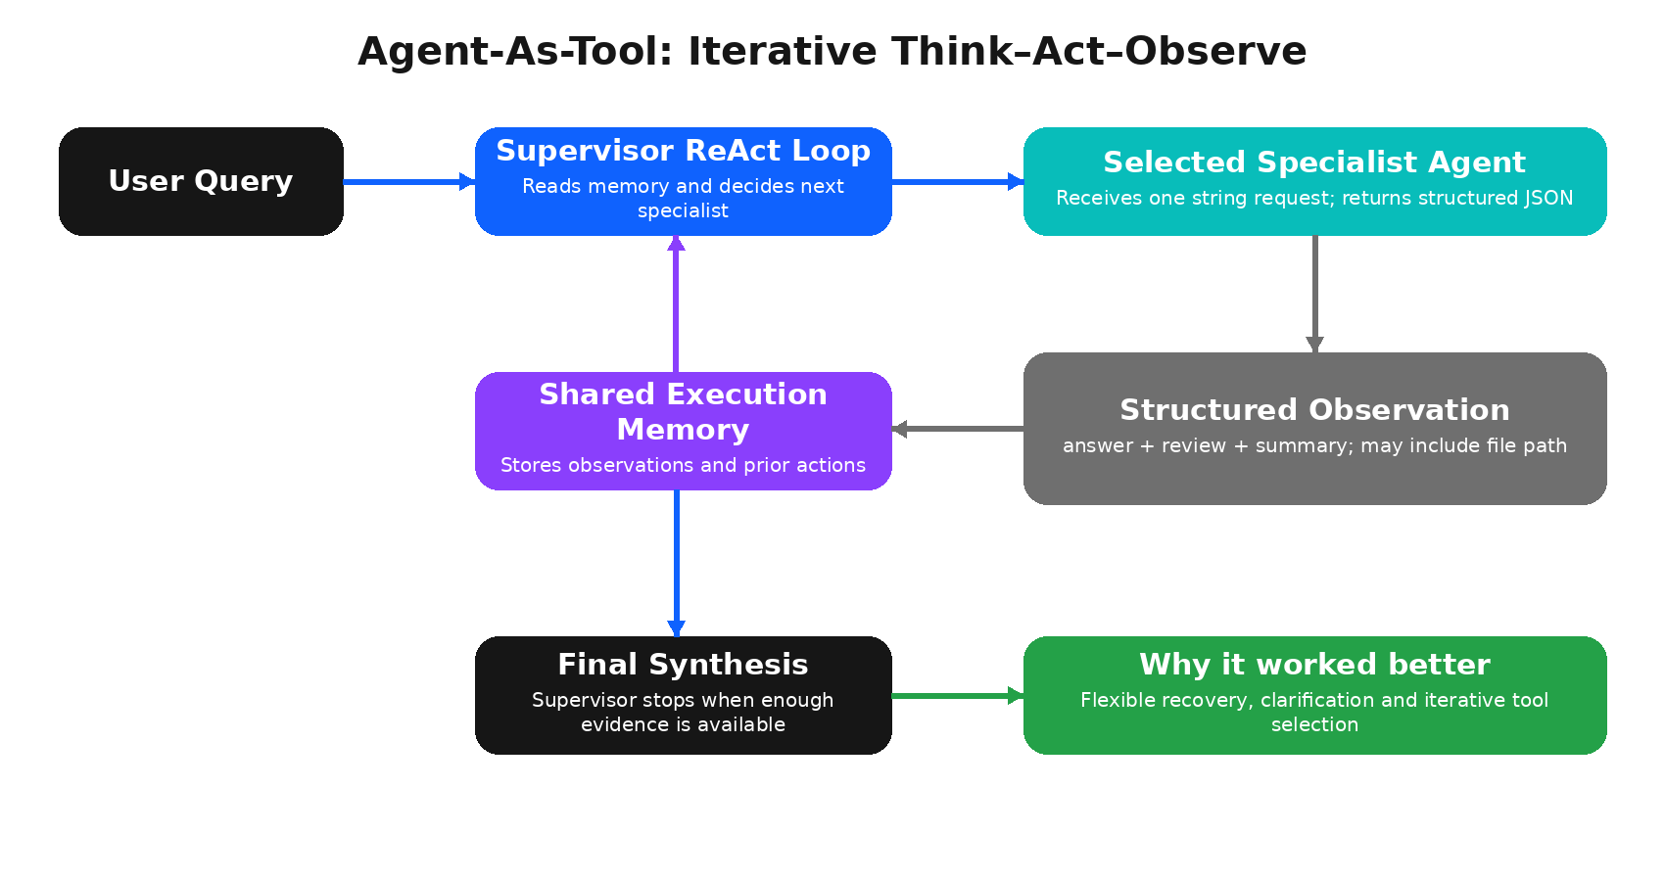
Figure 4. Agent-As-Tool uses an iterative supervisor loop and specialist agents as high-level tools.
In Agent-As-Tool, every domain agent is registered as a high-level tool. The supervisor follows a ReAct loop: it thinks about the current evidence, selects an agent, sends a request, observes the structured response, updates memory and decides the next step. The loop ends when the supervisor believes the task is complete or the maximum step limit is reached.
Strength | Why it matters
Adaptive execution | The next step can change after observing real data.
Natural error recovery | The supervisor can call another agent or revise a request after a failed tool call.
Clarification support | A specialist can ask the parent agent for missing information.
Strong end-task quality | The paper found higher completion than Plan-Execute for most models.

Its disadvantage is that it can take more tool steps because the agent decides incrementally. It may also loop or stop prematurely if the model’s ReAct reasoning is weak.

7.2 Plan-Execute
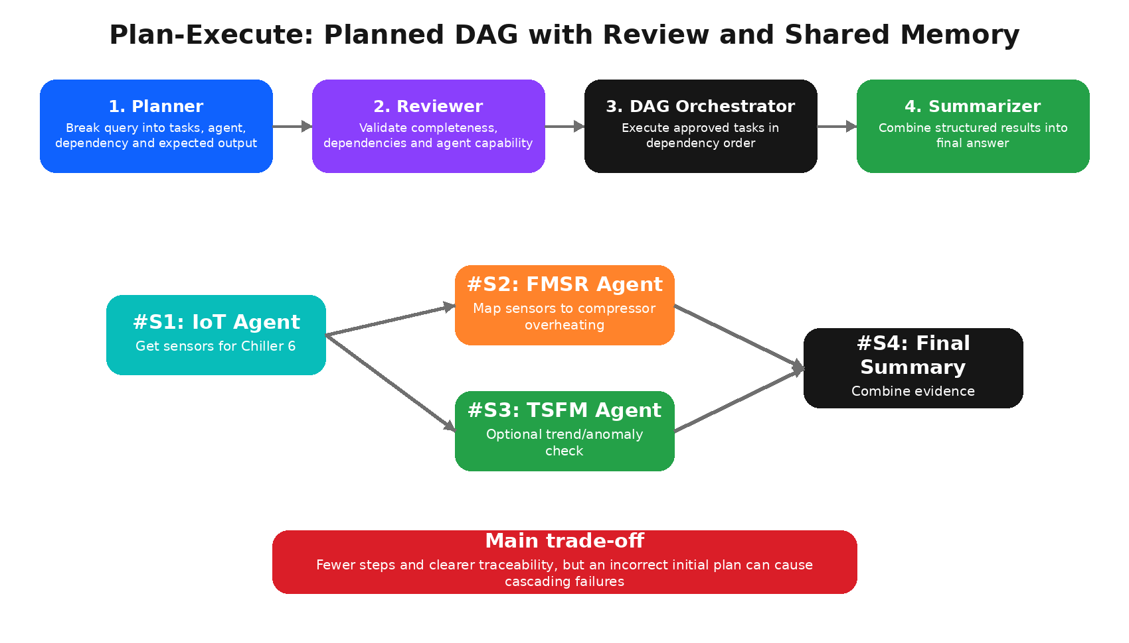
Figure 5. Plan-Execute creates, reviews and executes a dependency-aware DAG.
Plan-Execute separates planning from execution. A Planner produces steps containing a task, assigned agent, dependencies and expected output. A Reviewer checks whether the plan is complete and whether each step matches the selected agent’s capability. The approved plan is converted to a DAG and executed by an Orchestrator. A shared-memory module passes outputs between dependent tasks, and a Summarizer creates the final answer.
Strength | Limitation
Clear plan and dependencies | An incorrect plan is fixed early in the workflow and may cause cascading failure.
Potential parallel execution | Planner/reviewer overhead can increase latency.
Fewer execution steps | It may over-plan simple requests and does not always adapt well to unexpected observations.
Good traceability | Models that are strong at iterative tools may still perform poorly with rigid plan formats.

7.3 Interview comparison
Question | Agent-As-Tool | Plan-Execute
When are agents selected? | During execution, based on current memory. | Before execution in a planned DAG.
Recovery from unexpected data | Usually easier; choose a new action. | Harder if the plan did not anticipate the condition.
Step count | Usually higher. | Usually lower.
Traceability | Action-by-action trajectory. | Explicit plan, dependency graph and execution states.
Paper result | Higher best task completion: 65%. | Lower best task completion: 46%.

8. End-to-End Execution Example
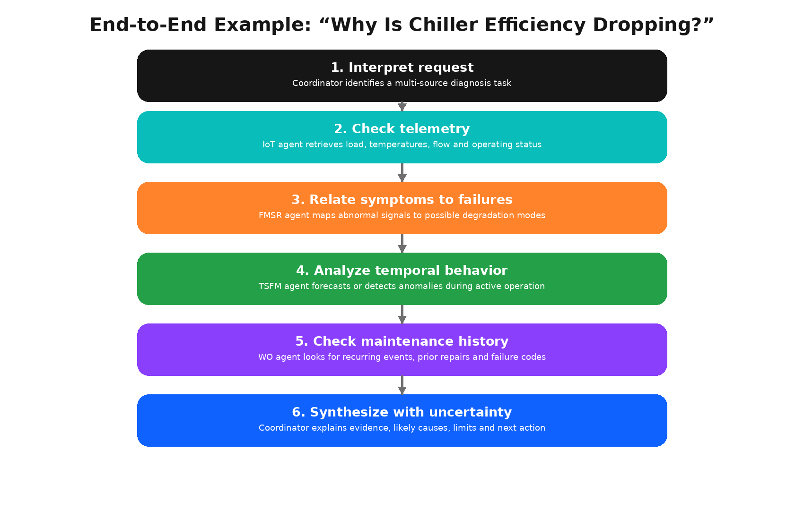
Figure 6. Example multi-agent diagnosis flow for a chiller-efficiency problem.

8.1 User question
Question
“Why has the efficiency of Chiller 6 been dropping, and what should the maintenance team check next?”

8.2 Step-by-step execution
1. The coordinator recognizes that the query needs telemetry, diagnostic reasoning and maintenance context. It does not send the question to every agent blindly.
2. The IoT Agent resolves the site and asset, retrieves run status, load, chilled-water temperatures, condenser-water flow and other relevant measurements for the requested period.
3. The coordinator checks whether the chiller was active. Inactive periods are separated so they do not distort trend or forecast analysis.
4. The FMSR Agent receives the abnormal observations plus the available sensor list. It maps the symptoms to plausible failures, such as flow restriction, fouling, refrigerant issues or component degradation, depending on the FMEA evidence.
5. The TSFM Agent analyzes the selected variables. It can forecast future behavior or identify anomalies during active operation. If the data window is unsuitable, it returns an explicit limitation.
6. The Work Order Agent checks previous alerts, anomalies, failure codes and maintenance interventions. It looks for repeated corrective work or a prior action that temporarily resolved a similar pattern.
7. The coordinator combines the findings. A good response distinguishes observed evidence from hypotheses, explains confidence and recommends a specific verification action rather than issuing an unsupported diagnosis.

8.3 Example of a good final answer
Illustrative answer (not a paper ground truth)
“The efficiency decline is supported by a rising temperature differential and abnormal condenser-flow behavior while the unit is running. The failure-mode mapping indicates that heat-transfer degradation or flow restriction should be checked first. Similar corrective work appears in the maintenance history. I recommend verifying condenser flow and heat-exchanger condition before changing the operating setpoint. The forecast is not used for inactive periods, and the evidence does not yet prove a single root cause.”

This example shows the desired response style: evidence first, hypothesis second, recommended action third, and uncertainty clearly stated.

9. Evaluation Methodology
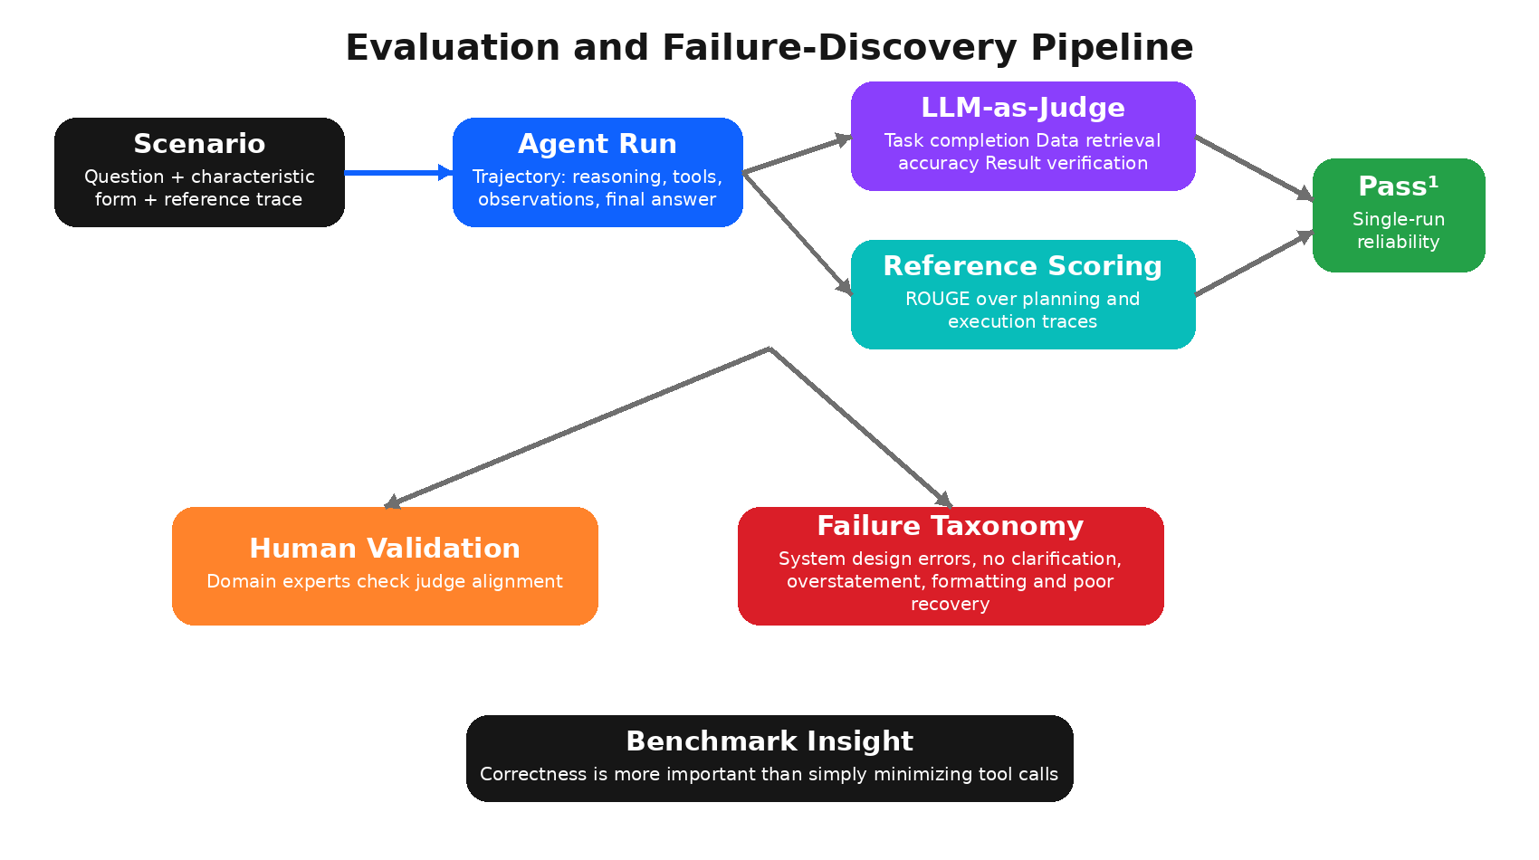
Figure 7. Evaluation combines rubric scoring, reference-trace scoring, reliability and failure discovery.

9.1 LLM-as-Judge scoring
Every scenario includes a characteristic form describing the expected behavior and procedural requirements. The evaluator receives the original question, expected behavior, agent reasoning and final response. Llama-4-Maverick is used as the primary judge because it aligned better with domain experts than the other tested judge candidate.
Metric | What the judge checks
Task Completion | Were all necessary actions performed with the right tools and analysis?
Data Retrieval Accuracy | Were the correct site, asset, sensors, time period and values used?
Generalized Result Verification | Does the output match the requested task type and expected result, with correct data integrity and format?

9.2 Reference-based scoring
Each scenario also contains reference planning steps, execution steps and causal links. The benchmark compares the generated plan or reasoning trace with this reference using ROUGE-1, ROUGE-2, ROUGE-L and ROUGE-Lsum. ROUGE indicates workflow/text overlap, not necessarily semantic correctness. A verbose but correct trajectory may receive lower ROUGE than a concise reference.

9.3 Reliability settings
- Pass¹: The default result represents success on a single execution, appropriate for settings where repeated stochastic retries are undesirable.
- Deterministic specialist agents: Temperature is set to zero to reduce variability in reasoning and tool selection.
- Judge averaging: The judge runs five times per trajectory and the scores are averaged.
- Human validation: Four domain experts evaluated a sample of tasks to measure agreement with the LLM judge.

9.4 Results and interpretation
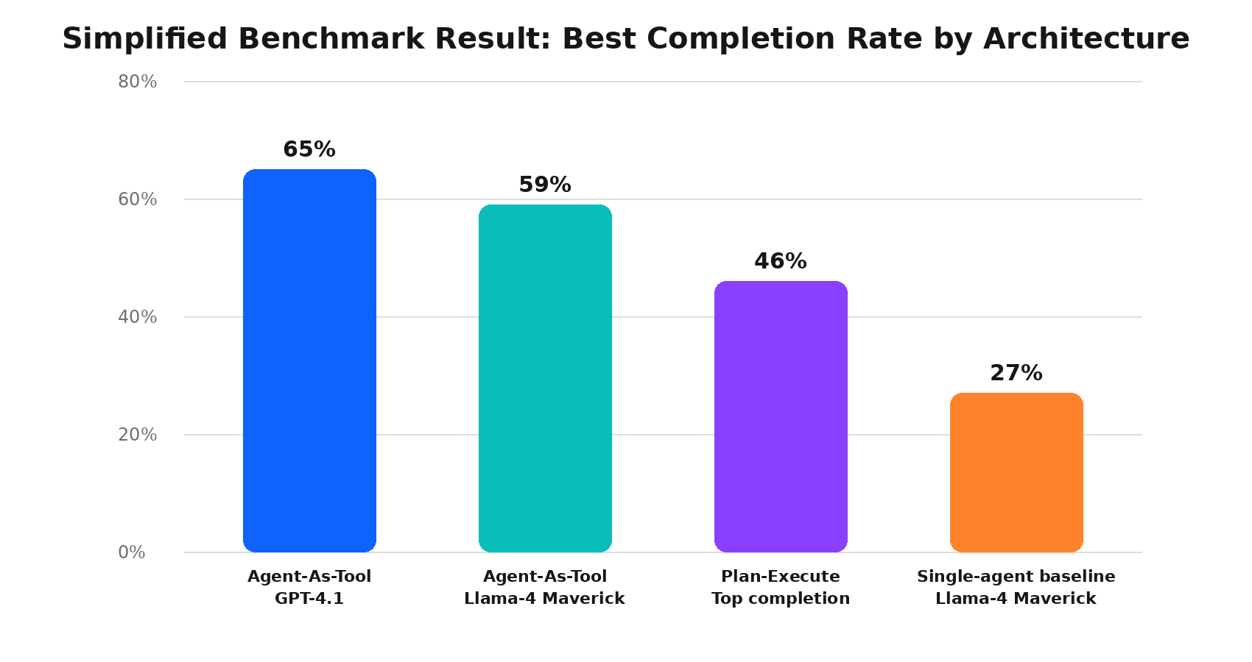
Figure 8. Simplified task-completion comparison using values reported in the paper.
Finding | Interview interpretation
GPT-4.1 reached 65% completion and 77% retrieval accuracy in Agent-As-Tool. | Even frontier models remain below production-grade reliability on the full benchmark.
The best Plan-Execute completion was 46%. | Fewer planned steps did not translate into higher end-task correctness.
Llama-4-Maverick was balanced across both strategies. | It was selected for ablations and as the judge after human-alignment testing.
Small models performed reasonably on IoT/FMSR/TSFM but poorly on work orders. | A hybrid architecture can use smaller specialists and a stronger coordinator/code agent.
The single-agent baseline achieved about 27% completion. | Specialization and hierarchical delegation reduced tool ambiguity and improved performance.

Key conclusion
The paper does not show that planning is always bad. It shows that, for these industrial tasks and tested models, flexible iterative delegation produced better end-task correctness than rigid upfront planning.

9.5 Failure analysis and lessons
AssetOpsBench analyzes 881 trajectories using a known taxonomy of agent failures and also allows the evaluator to discover new failure patterns. The purpose is diagnostic: a leaderboard score says how often the system succeeded, while the failure analysis explains why it failed.
Failure | What it looks like | How to improve
Fail to ask for clarification | The agent guesses an asset, site, sensor or period that the user did not specify. | Allow sub-agents to ask the parent agent; confirm critical parameters.
Overstatement of task completion | The response claims success although a required tool failed or a result was not verified. | Use structured review status and evidence-based completion checks.
Extraneous/ambiguous formatting | The result is difficult to parse or does not match the requested object/JSON form. | Enforce schemas and output validation.
Ineffective error recovery | The agent repeats the same failed call or terminates after one error. | Add retry policies, alternative tools and explicit recovery instructions.
System-design failure | The orchestration or interface makes the task difficult even when the model understands it. | Simplify tools, improve descriptions, reduce context and test agent-tool alignment.
Premature termination | The agent returns partial data without completing downstream analysis. | Track required subtasks and compare against the scenario characteristic form.

A practical change allowing specialists to ask clarifying questions increased Llama-4-Maverick task completion from 59% to 66% in Agent-As-Tool. This is a strong interview example of using trajectory analysis to improve system design rather than only changing the LLM.

10. Complete Technology Stack
Layer | Technology / approach | Role in the system
Programming | Python | Agent logic, tools, APIs, data handling and evaluation.
Agent reasoning | ReAct | Think–Act–Observe loop for IoT, FMSR, TSFM and the Agent-As-Tool supervisor.
Code reasoning | CodeReAct | Programmatic analysis of work-order business objects.
Orchestration | Agent-As-Tool; Plan-Execute with Planner, Reviewer, DAG Orchestrator and Shared Memory | Coordinates specialists and moves intermediate context.
Agent/tool framework | LangChain-style tools plus other open-source agent toolkits in the paper implementation | Defines tool schemas, calls functions and records trajectories.
Operational database | CouchDB | JSON-document backend for the simulated industrial environment.
Industrial systems represented | BMS, SkySpark, IBM Maximo, FMEA/Reliability Strategy Library | Sources for telemetry, work orders and reliability knowledge.
Time-series modelling | Pretrained Hugging Face TSFM | Forecasting, fine-tuning and anomaly detection.
Containerization | Docker | Reproducible local/competition execution and controlled access.
LLMs benchmarked | GPT-4.1, Llama-4 Maverick, Llama-4 Scout, Mistral Large, Llama-3 405B, Llama-3 70B, Granite 3 8B | Backbones for reasoning, tool selection and planning.
Evaluation | Llama-4-Maverick judge, ROUGE, Pass¹, human validation | Measures correctness, trace alignment and reliability.
Current repository evolution | Native MCP servers and multiple modern runners on the main branch | Standardizes tool exposure and supports additional orchestration frameworks.

10.1 Why CouchDB?
CouchDB stores JSON documents and fits the simulated environment because sensor metadata, work orders, events and relationship objects can be represented as structured documents. It also supports reproducible API access inside containers. CouchDB is an operational document database here; it is not used for semantic nearest-neighbor search.

10.2 Why Docker?
A benchmark must execute participant agents against the same interfaces and data conditions. Docker isolates dependencies, standardizes the environment and enables code-executed competition submissions without exposing real production systems.

10.3 Why This Project Is Not a RAG System
Direct answer
The research-paper implementation does not require an embedding model or vector database. Agents call structured tools and domain models rather than retrieving document chunks by semantic similarity.

RAG application | AssetOpsBench paper architecture
Chunks unstructured documents. | Works mainly with structured industrial APIs, time-series files and business objects.
Converts text/query to embeddings. | No central embedding generation stage is described.
Uses a vector database for similarity search. | Uses CouchDB as an operational JSON document store.
Retrieves context passages for generation. | Calls agents/tools for exact data, physical mappings, model execution and code analysis.
Primary risk: irrelevant/unsupported retrieved text. | Primary risks: wrong tool/parameters, invalid planning, poor recovery and unverified execution.

The FMSR mapping tool uses an LLM to relate failure modes and sensor semantics, but that does not automatically make the architecture RAG. Similarly, the paper mentions LLM-powered retrieval in the broad lifecycle taxonomy, yet its core benchmark tool architecture is structured tool calling rather than a document-vector pipeline.
Follow-up answer
“We could add RAG later for technical manuals, service bulletins or unstructured technician notes. That would be an additional knowledge agent or tool, not a replacement for exact telemetry and work-order APIs.”

11. Production Design, Scalability and Safety

11.1 How I would productionize it
1. Expose each specialist through a versioned API or MCP server with strict JSON schemas.
2. Use a message/trace identifier across coordinator, agents and tools for end-to-end observability.
3. Keep deterministic data operations outside the LLM. The LLM chooses tools; validated services perform calculations and database writes.
4. Separate read-only diagnostic tools from write tools such as work-order creation. Require approval for high-impact actions.
5. Add timeouts, circuit breakers, retry policies and idempotency keys for external industrial systems.
6. Cache stable metadata such as asset hierarchies, sensor lists and FMEA mappings, while applying shorter TTLs to live telemetry.
7. Use a policy layer to restrict each agent to its authorized sites, assets and actions.
8. Run offline evaluation and shadow-mode deployment before allowing automated maintenance actions.

11.2 Observability
What to log | Why
User request and resolved entities | Detect incorrect asset/site interpretation.
Selected agent and tool arguments | Audit routing and parameter accuracy.
Tool latency, errors and result size | Identify API bottlenecks and context explosions.
Intermediate summaries and review status | Understand how evidence changed the plan.
Final claims linked to evidence | Support audit and human verification.
Token usage and model version | Control cost and reproduce behavior.

11.3 Safety guardrails
- Read-before-write: diagnostic agents may read data freely within authorization, but work-order creation requires validation.
- Abstention: return “insufficient evidence” when the asset is inactive, fields are missing or tools disagree.
- Human-in-the-loop: maintenance recommendations and system changes are reviewed by an engineer.
- Schema validation: reject malformed tool calls and output objects before execution.
- Least privilege: each specialist receives only the tools required for its domain.

12. Interview Questions and Expected Follow-Up Answers
Q1. What exactly is AssetOpsBench?
It is a benchmark and simulated environment for building and evaluating industrial multi-agent systems. A coordinator delegates work to four domain agents that access telemetry, failure models, time-series models and work-order history.
Follow-up: Is it a product or benchmark?
Primarily a benchmark/framework. It imitates the architecture needed for a production assistant, but its central contribution is reproducible evaluation across realistic scenarios.
Q2. Why did the project use multiple agents?
The domains use different data, tools and reasoning. Specialization reduces tool ambiguity and prompt complexity. The single-agent baseline was much weaker, supporting hierarchical delegation.
Follow-up: Could one powerful LLM handle everything?
It could be exposed to every tool, but that increases selection errors and context size. A strong LLM may still coordinate specialists more reliably than directly managing all low-level tools.
Q3. What is the role of the coordinator?
It interprets user intent, selects specialist agents, passes intermediate context, handles termination and produces the final answer.
Follow-up: Does it query CouchDB directly?
Conceptually it should delegate domain retrieval to the relevant agent/tool. Direct access would weaken specialization and make authorization harder.
Q4. Explain the IoT Agent.
It discovers sites/assets/sensors and retrieves historical telemetry for an exact time range. It returns structured metadata or a JSON file path rather than inventing sensor values.
Follow-up: How does it handle large sensor histories?
The history tool can store observations in a file and return a summary plus path. JSONReader loads detailed content only when needed.
Q5. Explain the FMSR Agent.
It retrieves FMEA failure modes and maps them to relevant sensors, bridging physical reliability terms and actual sensor tags.
Follow-up: Is this mapping deterministic?
Failure retrieval is structured; the relevancy mapping can be LLM-driven and therefore needs evidence, review and controlled output.
Q6. Explain the TSFM Agent.
It uses an LLM for task/model selection and a pretrained time-series foundation model for forecasting, fine-tuning or anomaly detection.
Follow-up: Why not let the LLM forecast directly?
LLMs are not reliable numerical time-series estimators. A dedicated TSFM provides a grounded modelling component.
Q7. Why does the Work Order Agent use CodeReAct?
Maintenance analysis needs filtering, grouping, joins and trends across many structured objects. Code execution is more reliable than asking an LLM to mentally process thousands of records.
Follow-up: What is the main risk of code execution?
Unsafe or inefficient code. Production systems need a sandbox, resource limits, restricted libraries, read-only data and output validation.
Q8. Agent-As-Tool vs Plan-Execute?
Agent-As-Tool chooses specialists iteratively after each observation. Plan-Execute creates and reviews a dependency graph before executing it.
Follow-up: Which performed better?
Agent-As-Tool achieved the stronger task-completion result in the paper. Plan-Execute used fewer steps but suffered cascading errors when the initial plan was wrong.
Q9. Why is this not RAG?
There is no central document chunking, embedding and vector retrieval pipeline. Agents call structured APIs, a document database, time-series models and code tools.
Follow-up: Where could RAG help?
Technical manuals, maintenance notes, service bulletins and troubleshooting documents could be exposed through an additional RAG knowledge agent.
Q10. Why CouchDB?
It is a JSON document database suitable for structured simulated industrial objects and containerized APIs. It is not a vector database.
Q11. How was the system evaluated?
Using LLM-as-Judge on task completion, data retrieval accuracy and result verification; ROUGE for reference-trace alignment; Pass¹ for single-run reliability; and human validation of the judge.
Follow-up: What is a weakness of LLM-as-Judge?
It can be biased or inconsistent. AssetOpsBench mitigates this by repeated judging, human comparison and a separate reference-based score.
Q12. What was the biggest lesson from failure analysis?
Many failures came from system design and communication, not only model intelligence. Enabling clarification improved completion significantly.
Q13. How would you reduce latency?
Cache metadata, shorten tool outputs, parallelize independent DAG tasks, select smaller specialist models, preload TSFM checkpoints and avoid unnecessary JSONReader calls.
Q14. How would you prevent hallucination?
Keep data operations in deterministic tools, verify tool success, link final claims to observations, require abstention on missing data and use human approval for actions.
Q15. What would you improve next?
Add typed knowledge graphs for asset relationships, stronger schema validation, confidence-aware routing, temporal caching, human feedback and document RAG as a separate agent.

13. Five-Minute Interview Script
The project I would like to explain is AssetOpsBench, an IBM Research benchmark for industrial asset operations and maintenance. The business problem is that industrial assets such as data-center chillers generate several different kinds of data: sensor telemetry, alerts, failure-mode records and maintenance work orders. Engineers usually have to combine these sources manually before they can diagnose an issue or decide the next maintenance action.
AssetOpsBench solves this as a multi-agent system. A global AssetOps Agent receives the user’s natural-language question and coordinates four specialist agents. The IoT Agent retrieves sites, assets, sensors and historical readings. The FMSR Agent retrieves FMEA failure modes and maps failures to relevant sensors. The TSFM Agent uses a pretrained time-series foundation model for forecasting and anomaly detection. The Work Order Agent uses CodeReAct to analyze maintenance and event business objects, because these tasks require filtering, aggregation and multi-step logic.
The system supports two orchestration methods. In Agent-As-Tool, the coordinator uses a ReAct loop and selects specialist agents iteratively based on current evidence. In Plan-Execute, a Planner first creates tasks and dependencies, a Reviewer validates the plan, and an Orchestrator executes the DAG using shared memory. In the experiments, Agent-As-Tool produced better task completion, although it generally used more steps.
The data layer is a Dockerized, CouchDB-backed simulated industrial environment. The benchmark includes more than 2.3 million sensor readings, 53 FMEA records, around 4.2 thousand work orders and 141 expert-created scenarios. It preserves realistic problems such as missing values, inactive asset periods and imperfect timestamp alignment.
This is not a traditional RAG project. There is no central embedding model or vector database. The agents retrieve exact structured data through tools and run dedicated time-series or code-based analysis. RAG could be added later for manuals and technician notes.
Finally, the system evaluates complete trajectories using an LLM-as-Judge for task completion, data accuracy and result verification, along with ROUGE-based reference scoring and human validation. The important learning is that a reliable agent depends not only on the LLM but also on agent specialization, tool design, clarification, recovery and verification.
Delivery tip
Do not memorize every sentence. Remember the sequence: problem → architecture → four agents → orchestration → data/tech stack → evaluation → key result.

13.1 Ten-Minute Expansion Guide
To expand the five-minute answer to ten minutes, add one concrete example and one technical result after each major section:
Minute | What to explain | Example detail
0–1 | Definition and industrial pain | Different systems and operator-level question.
1–2 | Data and benchmark | 2.3M telemetry points, 53 FMEA records, 4.2K work orders, 141 scenarios.
2–5 | Architecture and agents | Explain each agent and why WO uses CodeReAct.
5–6.5 | Orchestration | Compare iterative delegation and planned DAG.
6.5–8 | End-to-end chiller example | Telemetry → failure mapping → TSFM → work-order history → synthesis.
8–9 | Evaluation and results | Three judge metrics, human validation, 65% vs 46% completion.
9–10 | Limitations and improvements | No RAG in core; add document agent, guardrails and human approval.

A useful whiteboard explanation
Draw five boxes: User → Coordinator → Four Agents → Tools/Data → Final Answer. Then draw a side box named Evaluation that receives the full trajectory. This is enough to communicate the core system design clearly.

What not to say
- Do not say the project uses Chroma, Pinecone, FAISS or an embedding model unless you are specifically describing a separate extension.
- Do not say the LLM directly predicts the time series; the TSFM tool performs the numerical task.
- Do not say Plan-Execute is universally worse; state that it underperformed for the tested benchmark/models.
- Do not claim the system autonomously controls production assets; it is a simulated benchmark and decision-support architecture.
- Do not claim personal implementation work that you did not actually perform.

14. Positioning Your Personal Contribution Honestly
Interviewers often ask, “What did you personally do?” The answer must match your real work. Use one of the following structures and replace the bracketed details.
If you implemented or reproduced the project
“I studied the paper architecture and reproduced the [agent/tool/evaluation] workflow. My main responsibility was [specific module]. I configured [model/tool/database], tested it on [scenarios], analyzed [metrics/failures], and improved [latency/accuracy/recovery].”

If it was a research/learning project
“I used AssetOpsBench as a reference project to understand industrial multi-agent systems. I analyzed the architecture, ran or reviewed scenarios, compared orchestration strategies and documented how the agents interact with structured data. I would describe my contribution as implementation analysis and experimentation rather than authorship of the IBM framework.”

If you built a related custom version
“My system was inspired by AssetOpsBench. I adapted the pattern to [your domain], implemented [your agents/tools], used [your actual stack], and evaluated it using [your actual metrics]. The IBM benchmark was the architectural reference, not code I claim to have authored.”

Final cheat sheet
Remember | Answer
Project type | Industrial multi-agent benchmark and simulated environment.
Coordinator | Global AssetOps Agent.
Agents | IoT, FMSR, TSFM, Work Order.
Reasoning | ReAct for most agents; CodeReAct for work orders.
Orchestration | Agent-As-Tool and Plan-Execute.
Backend | Docker + CouchDB-backed industrial sandbox.
Time series | Pretrained Hugging Face TSFM.
Data | 2.3M+ points, 53 FMEA, 4.2K work orders, 141 scenarios.
Evaluation | Task completion, data accuracy, result verification, ROUGE, Pass¹ and human validation.
Best paper result | Agent-As-Tool GPT-4.1: 65% completion, 77% retrieval.
Not included in core | No central embeddings/vector DB/RAG pipeline.
Main lesson | Good tools, specialization, clarification and recovery matter as much as the LLM.

References and Source Note
This handbook paraphrases and reorganizes the source material for interview preparation. Diagrams are original recreations based on the architecture and workflows described in the sources.
1. Patel, D., Lin, S., Rayfield, J., Zhou, N., et al. (2026). AssetOpsBench: A Real-World Evaluation Benchmark for AI-Driven Task Automation in Industrial Asset Management. arXiv:2506.03828.
2. IBM. AssetOpsBench GitHub repository. https://github.com/IBM/AssetOpsBench (repository checked July 2026).
3. IBM Research. Meet AssetOpsBench, IBM’s first Industry 4.0 benchmark. IBM Research Blog.
4. Yao, S., et al. (2023). ReAct: Synergizing Reasoning and Acting in Language Models.
5. Wang, X., et al. (2024). CodeReAct: a framework combining reasoning, actions and executable code.
Accuracy note
The live repository is actively developed and may list more scenarios, MCP tools and agent runners than the 2026 paper version. For interview consistency, quote paper numbers when explaining the published benchmark and explicitly label newer repository features as later evolution.

